湖北文理学院理工学院实验报告
学 期： 2025 ― 2026 学年度 上 学期
课程名称： javaweb程序设计 指导教师： 彭愿庆
学号： 266430069 姓名： 段辉园 班级： 计科2632
实验报告内容及格式参考：  一、实验项目名称；二、实验器材；三、实验原理；四、实验内容及步骤；五、实验过程记录；六、实验数据处理；七、实验结果及分析；八、实验总结/心得。 | 教师评分：
- 实验项目名称

实验三 会话技术

- 实验目的与要求

1.掌握会话技术的作用与原理；
2.掌握Cookie的生命周期及使用
3.掌握Session的生命周期及使用

- 实验环境

Windows11+Linux

四、实验内容与步骤

- 实验内容：

1.使用Cookie技术实现登录业务的两周不用登录功能
2.使用Session技术实现登录成功后即可操作其它功能。

- 实验步骤：

- 登录页面设计

要求：粘贴核心代码
答：
- login.html:
<body>
<div class="box">
<h2>用户登录</h2>
<p class="err" id="errMsg"></p>
<form action="login" method="post">
<label class="field">用户名</label>
<input type="text" name="username" placeholder="请输入用户名" required>
<label class="field">密&nbsp;&nbsp;码</label>
<input type="password" name="password" placeholder="请输入密码" required>
<p style="margin-top:14px;">
<label><input type="checkbox" name="remember"> 两周不用登录</label>
</p>
<button type="submit">登 录</button>
</form>
<p class="tip">测试账号：admin / 123456</p>
</div>
<script>
(function () {
var params = new URLSearchParams(window.location.search);
var error = params.get('error');
var el = document.getElementById('errMsg');
if (error === '1') {
el.textContent = '用户名或密码错误！';
} else if (error === 'needLogin') {
el.textContent = '请先登录后再访问！';
}
})();
</script>
</body>

- welcome.html:

<body>
<div class="box">
<h2>欢迎你，<span id="user">...</span>！</h2>
<div class="info">
<p>Session ID：<span id="sessionId"></span></p>
<p>Session 创建时间：<span id="createTime"></span></p>
<p>Session 最后访问时间：<span id="lastTime"></span></p>
<p>Session 最大不活动间隔：<span id="maxInactive"></span> 秒</p>
</div>
<a class="btn" href="info.html">查看个人信息</a>
<a class="btn" href="logout">退出登录</a>
</div>
<script>
fetch('userinfo')
.then(function (r) { return r.json(); })
.then(function (data) {
if (data.code !== 200) { location.href = 'login.html?error=needLogin'; return; }
document.getElementById('user').textContent = data.user;
document.getElementById('sessionId').textContent = data.sessionId;
document.getElementById('createTime').textContent = data.createTime;
document.getElementById('lastTime').textContent = data.lastTime;
document.getElementById('maxInactive').textContent = data.maxInactive;
});
</script>
</body>

- info.html:
<body>
<div class="box">
<h2>个人信息（需登录才能访问）</h2>
<ul>
<li>用户名：<span id="user">...</span></li>
<li>角色：管理员</li>
<li>登录方式：Session 已认证</li>
</ul>
<a href="welcome.html">返回主页</a>
</div>
<script>
fetch('userinfo')
.then(function (r) { return r.json(); })
.then(function (data) {
if (data.code !== 200) { location.href = 'login.html?error=needLogin'; return; }
document.getElementById('user').textContent = data.user;
});
</script>
</body>

- 完成登录功能

注意：登录的用户名/密码统一设置成admin/123456
要求：粘贴核心代码
答：
- AuthFilter:
@WebFilter(urlPatterns = {"/login.html", "/welcome.html", "/info.html"})
public class AuthFilter implements Filter {
private static final String USERNAME = "admin";
private static final String PASSWORD = "123456";
@Override
public void doFilter(ServletRequest request, ServletResponse response, FilterChain chain)
throws IOException, ServletException {
HttpServletRequest req = (HttpServletRequest) request;
HttpServletResponse resp = (HttpServletResponse) response;
HttpSession session = req.getSession(false);
String user = (session == null) ? null : (String) session.getAttribute("user");
if (user == null) {
String cookieUser = null, cookiePwd = null;
Cookie[] cookies = req.getCookies();
if (cookies != null) {
for (Cookie c : cookies) {
if ("loginUser".equals(c.getName())) {
cookieUser = URLDecoder.decode(c.getValue(), "UTF-8");
} else if ("loginPwd".equals(c.getName())) {
cookiePwd = URLDecoder.decode(c.getValue(), "UTF-8");
}
}
}
if (USERNAME.equals(cookieUser) && PASSWORD.equals(cookiePwd)) {
session = req.getSession(true);
session.setAttribute("user", cookieUser);
session.setMaxInactiveInterval(30 * 60);
user = cookieUser;
}
}
String uri = req.getRequestURI();
if (user != null && uri.endsWith("/login.html")) {
resp.sendRedirect(req.getContextPath() + "/welcome.html");
return;
}
if (user == null && !uri.endsWith("/login.html")) {
resp.sendRedirect(req.getContextPath() + "/login.html?error=needLogin");
return;
}
chain.doFilter(request, response);
}
}

- LoginServlet：
@WebServlet("/login")
public class LoginServlet extends HttpServlet {
private static final String USERNAME = "admin";
private static final String PASSWORD = "123456";
@Override
protected void doPost(HttpServletRequest req, HttpServletResponse resp)
throws ServletException, IOException {
req.setCharacterEncoding("UTF-8");
resp.setContentType("text/html;charset=UTF-8");
String username = req.getParameter("username");
String password = req.getParameter("password");
String remember = req.getParameter("remember");
if (!USERNAME.equals(username) || !PASSWORD.equals(password)) {
resp.sendRedirect(req.getContextPath() + "/login.html?error=1");
return;
}
HttpSession session = req.getSession();
session.setAttribute("user", username);
session.setMaxInactiveInterval(30 * 60);
if ("on".equals(remember)) {
Cookie cookieUser = new Cookie("loginUser",
URLEncoder.encode(username, "UTF-8"));
Cookie cookiePwd = new Cookie("loginPwd",
URLEncoder.encode(password, "UTF-8"));
int maxAge = 14 * 24 * 60 * 60; // 14 天 = 1209600 秒
cookieUser.setMaxAge(maxAge);
cookiePwd.setMaxAge(maxAge);
cookieUser.setPath(req.getContextPath());
cookiePwd.setPath(req.getContextPath());
resp.addCookie(cookieUser);
resp.addCookie(cookiePwd);
}
resp.sendRedirect(req.getContextPath() + "/welcome.html");
}
@Override
protected void doGet(HttpServletRequest req, HttpServletResponse resp)
throws ServletException, IOException {
doPost(req, resp);
}
}

- LogoutServlet

@WebServlet("/logout")
public class LogoutServlet extends HttpServlet {
@Override
protected void doGet(HttpServletRequest req, HttpServletResponse resp) throws IOException {
HttpSession session = req.getSession(false);
if (session != null) {
session.invalidate();
}
Cookie cookieUser = new Cookie("loginUser", "");
Cookie cookiePwd = new Cookie("loginPwd", "");
cookieUser.setMaxAge(0);
cookiePwd.setMaxAge(0);
cookieUser.setPath(req.getContextPath());
cookiePwd.setPath(req.getContextPath());
resp.addCookie(cookieUser);
resp.addCookie(cookiePwd);
resp.sendRedirect(req.getContextPath() + "/login.html");
}
}
- UserInfoServlet
@WebServlet("/userinfo")
public class UserInfoServlet extends HttpServlet {
@Override
protected void doGet(HttpServletRequest req, HttpServletResponse resp) throws IOException {
resp.setContentType("application/json;charset=UTF-8");
PrintWriter out = resp.getWriter();
HttpSession session = req.getSession(false);
String user = (session == null) ? null : (String) session.getAttribute("user");
if (user == null) {
resp.setStatus(HttpServletResponse.SC_UNAUTHORIZED);
out.print("{\"code\":401,\"msg\":\"未登录\"}");
return;
}
SimpleDateFormat sdf = new SimpleDateFormat("yyyy-MM-dd HH:mm:ss");
String sessionId = session.getId();
String createTime = sdf.format(new Date(session.getCreationTime()));
String lastTime = sdf.format(new Date(session.getLastAccessedTime()));
int maxInactive = session.getMaxInactiveInterval();
String json = "{"
+ "\"code\":200,"
+ "\"user\":\"" + user + "\","
+ "\"sessionId\":\"" + sessionId + "\","
+ "\"createTime\":\"" + createTime + "\","
+ "\"lastTime\":\"" + lastTime + "\","
+ "\"maxInactive\":" + maxInactive
+ "}";
out.print(json);
}
}

- 完成两周不用登录功能
要求：粘贴核心代码
答：
@WebServlet("/login")
public class LoginServlet extends HttpServlet {
private static final String USERNAME = "admin";
private static final String PASSWORD = "123456";

@Override
protected void doPost(HttpServletRequest req, HttpServletResponse resp)
throws ServletException, IOException {
req.setCharacterEncoding("UTF-8");
resp.setContentType("text/html;charset=UTF-8");
String username = req.getParameter("username");
String password = req.getParameter("password");
String remember = req.getParameter("remember");
if (!USERNAME.equals(username) || !PASSWORD.equals(password)) {
resp.sendRedirect(req.getContextPath() + "/login.html?error=1");
return;
}
HttpSession session = req.getSession();
session.setAttribute("user", username);
session.setMaxInactiveInterval(30 * 60); // Session 30 分钟不活动失效
if ("on".equals(remember)) {
Cookie cookieUser = new Cookie("loginUser",
URLEncoder.encode(username, "UTF-8"));
Cookie cookiePwd = new Cookie("loginPwd",
URLEncoder.encode(password, "UTF-8"));
int maxAge = 14 * 24 * 60 * 60; // 14 天 = 1209600 秒
cookieUser.setMaxAge(maxAge);
cookiePwd.setMaxAge(maxAge);
cookieUser.setPath(req.getContextPath());
cookiePwd.setPath(req.getContextPath());
resp.addCookie(cookieUser);
resp.addCookie(cookiePwd);
}
resp.sendRedirect(req.getContextPath() + "/welcome.html");
}
@Override
protected void doGet(HttpServletRequest req, HttpServletResponse resp)
throws ServletException, IOException {
doPost(req, resp);
}
}

- 启动Tomcat并访问页面

要求：截图记录在浏览器访问效果

答：

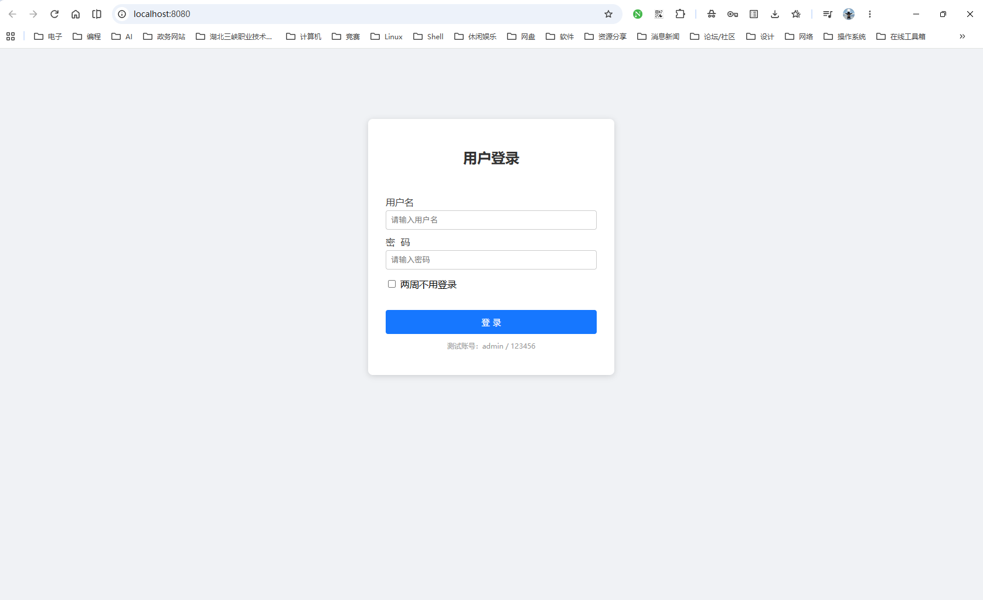

- 实验结果
答：见下图：
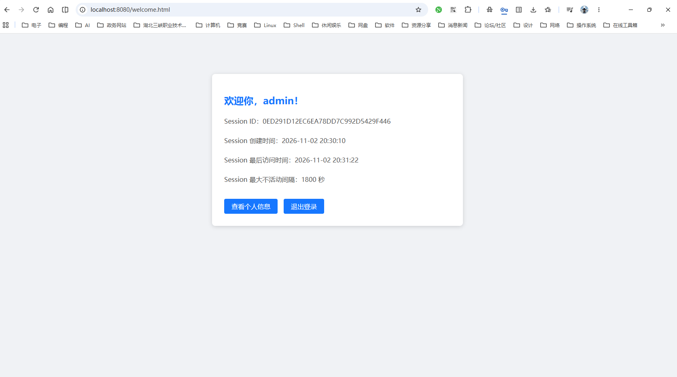

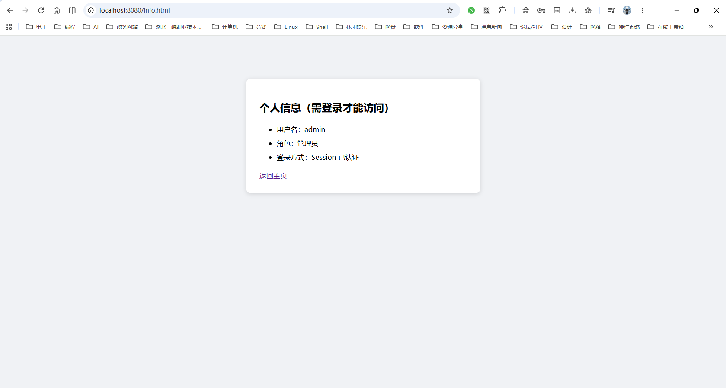
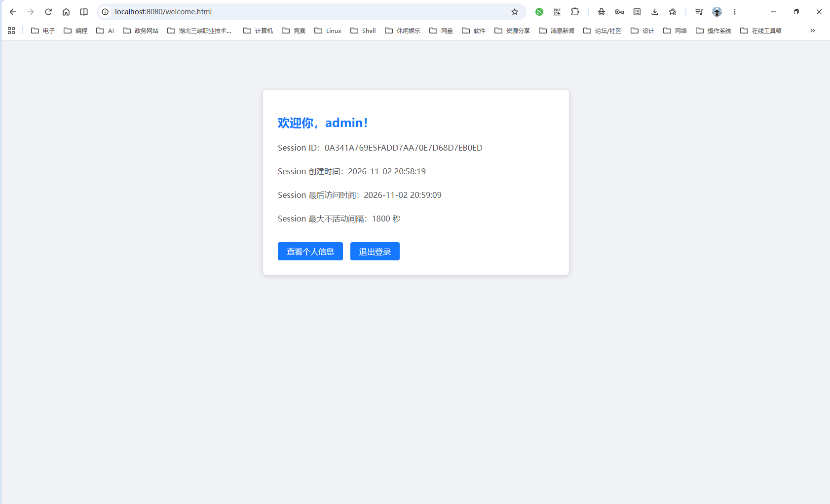

六、实验总结
答：
- 通过本次实验掌握的技能：
通过本次实验，我掌握了 Cookie 和 Session 的基本用法。Cookie 方面，学会了创建、读取、删除 Cookie，理解了 MaxAge 控制有效期（两周免登录就是设成 14 天）、Path 要设成项目路径才能被整个项目访问。Session 方面，学会了用 getSession() 存用户信息、用 invalidate() 退出登录，也理解了 Session 是靠 JSESSIONID 这个 Cookie 来关联的。另外还学会了用 Filter 统一做登录拦截和 Cookie 自动登录，以及用 Servlet 返回 JSON、HTML 页面用 fetch 取数据来显示用户名等信息。

- 编程能力提升及体现：
这次实验让我对“会话”的理解从只会调 API 变成了知道它背后怎么运作。比如做免登录时，一开始 Cookie 老是读不到，后来发现是 Path 没设对；还有 Filter 拦截范围写大了，把 userinfo 也拦了，导致页面一直跳登录页，通过看 F12 的 Network 和 Cookies 才找到原因。这些调试过程让我学会了先看现象再定位问题。另外因为不能用 JSP，我改用“Servlet 返回 JSON + 前端 fetch 渲染”的方式，体会到了前后端分开写其实更清晰。整体上，代码从“能跑就行”慢慢变得结构更清楚，也养成了注意路径、有效期这些细节的习惯。

